Kosovo – Society in Transition
(A young native’s point of view)

Drenusha Myha

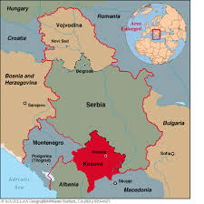
- A historical overview of Kosovo;
Conflicts with Serbia;
The war of 1999

- Kosovo’s transitional process from oppression to its road towards democracy.
System transformation: political, social and national transition.

- Unemployment: special focus with the youth unemployment as the majority of the population.

- The role of religion in politics and in general.

- Education: before the war and now.

- Minority’s life in Kosovo.

- The role and main scope of non-governmental organization; a closer look to my work with the NGO-s.

- Kosovo’s road ahead; its future.

